**Санкт-Петербургский национальный исследовательский университет информационных технологий, механики и оптики.**

Факультет Программной Инженерии и Компьютерной Техники



Лабораторная работа №4

предмет «Программирование» вариант 311217

ФИО: Фам Мань Туан

Группа: P3112

Преподаватель: Максимов Андрей Николаевич

Перцев Тимофей Сергеевич

**Санкт-Петербург 2020 г.**

Задание:

1. Доработать объектную модель приложения.
2. Перерисовать диаграмму классов в соответствии с внесёнными в модель изменениями.
3. Согласовать с преподавателем изменения, внесённые в модель.
4. Модифицировать программу в соответствии с внесёнными в модель изменениями.

Описание предметной области, по которой должна быть построена объектная модель:

И все они отправились искать Кенгу. Кенга и Ру мирно проводили послеобеденное время у большой ямы с песком. Крошка Ру упражнялся в прыжках в высоту и в длину и даже в глубину -- учился падать в мышиные норы и вылезать из них, а Кенга волновалась и поминутно приговаривала: "Ну, дорогой мой, еще один раз прыгни, и домой". И в этот момент на холме появился не кто иной, как Пух.

And they all went to look for Kanga. Kanga and Roo spent their afternoons peacefully by the large sand pit. Little Roo practiced high and long jumps and even deep jumps - he learned to fall into and out of mouse holes, and Kanga was worried and repeated every minute: "Well, my dear, jump one more time and go home." And at that moment, none other than Pooh appeared on the hill.

Диаграмма класс

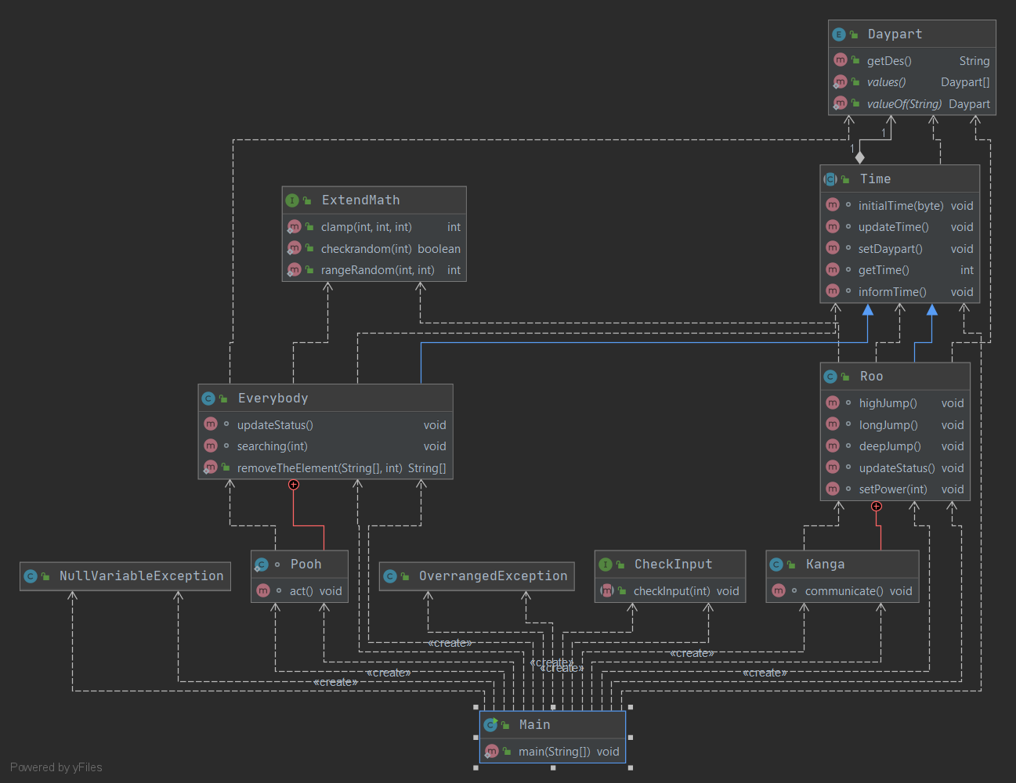

Исходный код

<https://github.com/7upn5mk/program/tree/main/lab4>

Результат работы

*Программа использует случайную функцию, поэтому не каждое выполнение будет давать одинаковый результат.

Roo was created

Everybody was created

Ranga was created

Pooh was created

Set the initial time (0-23): 0

12 P.M. Midnight

Roo failed the deep jump

Roo failed the high jump

Roo failed the long jump

Kanga was worried and told Roo to go home

Pooh was searching for Roo with everybody else

1 A.M. Night

Roo failed the deep jump

Roo failed the high jump

Roo failed the long jump

Kanga was worried and told Roo to go home

Pooh was searching for Roo with everybody else

2 A.M. Night

Roo failed the deep jump

Roo failed the high jump

Roo failed the long jump

Kanga was worried and told Roo to go home

Pooh was searching for Roo with everybody else

3 A.M. Night

Roo failed the deep jump

Roo failed the high jump

Roo failed the long jump

Kanga was worried and told Roo to go home

Pooh was searching for Roo with everybody else

4 A.M. Night

Roo failed the deep jump

Roo failed the high jump

Roo failed the long jump

Kanga was worried and told Roo to go home

Pooh was searching for Roo with everybody else

5 A.M. Night

Roo failed the deep jump

Roo failed the high jump

Roo failed the long jump

Kanga was worried and told Roo to go home

Last Night everybody searched Kaspiretskbut still didnt find Roo yet

Pooh was searching for Roo with everybody else

6 A.M. Sunrise

In the Morning, Roo at full of power

Roo did the deep jump succesfully

Roo did the high jump succesfully

Roo did the long jump succesfully

Kanga congratulated Roo

Pooh was searching for Roo with everybody else

7 A.M. Morning

Roo did the deep jump succesfully

Roo did the high jump succesfully

Roo did the long jump succesfully

Kanga congratulated Roo

Pooh was searching for Roo with everybody else

8 A.M. Morning

Roo did the deep jump succesfully

Roo did the high jump succesfully

Roo did the long jump succesfully

Kanga congratulated Roo

Pooh was searching for Roo with everybody else

9 A.M. Morning

Roo did the deep jump succesfully

Roo did the high jump succesfully

Roo did the long jump succesfully

Kanga congratulated Roo

Pooh was searching for Roo with everybody else

10 A.M. Morning

Roo did the deep jump succesfully

Roo did the high jump succesfully

Roo did the long jump succesfully

Kanga congratulated Roo

Pooh was searching for Roo with everybody else

11 A.M. Morning

Roo did the deep jump succesfully

Roo did the high jump succesfully

Roo did the long jump succesfully

Kanga congratulated Roo

Pooh was searching for Roo with everybody else

12 A.M. Noon

In the Afternoon, Roo can jump well

Roo did the deep jump succesfully

Roo did the high jump succesfully

Roo failed the long jump

Kanga was worried and told Roo to go home

Last Morning everybody searched Borisoluga and Myshinyye Nory and Polenezh. Finally, they found Roo at Myshinyye Nory

Pooh appeared on the hill

Process finished with exit code 0

Вывод:

После выполнения этой лабораторной работы я научился использовать вложенный класс в Java и отлаживать программу с помощью try catch.